For our project, we used Google Chrome to test our application, as well as the default browser for checking up on the remote repo, database, and to install all dependencies.

To get up to speed with where we leave off in development for a Basic LMS on Facebook should not be a long or difficult process. There are a few resources you are going to need to start working. In no particular order, they are:

1. Configure your Development Environment
   1. Install NodeJs (LTS recommended)
   2. Install npm (if not included with NodeJs installation)
   3. Install Angular CLI
   4. Generate SSL Key and Certificates
2. Access to Project Source Code
   1. A zip file containing the source code will be provided
   2. Extract the Project folder into the development environment
3. Get Project Dependencies
   1. In both , the backend and client root folders, run

(npm install )

1. Access to the Firebase Database Instance
   1. If you don’t have a Google account create one and signup for Google Cloud Platform
   2. Create a new project
   3. Create a new Firebase Instance
   4. Generate an access key (learnfiu_db.json) and place it in the backend’s root directory
2. Access to the Facebook App from developers.Facebook.com
   1. The same process as above applies, you will need to go to <https://developers.facebook.com>, and set up an account
   2. Replace every instance of the appId with your own

Once you have access to all 3 of these you will need to install an IDE or a code editor. I used IntelliJ, and my partner, Joao, used VSCode. Either will work just fine.

Now that you have installed an IDE, extract contents in the .Zip provided by the professor into the folder that contains the projects for your IDE or code editor.

Next, you will need to install all the necessary dependencies. However, before we install the dependencies, we will want to open the project in your IDE or code editor.

To do this, first open a new window of your IDE or code editor, then open a new terminal prompt and type the command: “cd FB_Basic_LMS”.

From here you can install the required dependencies. Below is a photo of the versions I currently am using as of 11/29/2019.

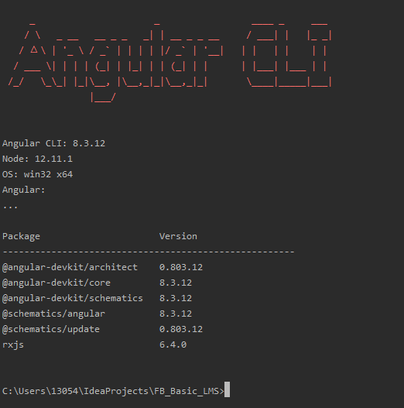

To get started with each:

1. First open up a new Chrome window and navigate to <https://nodejs.org/en/>
   1. Download and Install the LTS version, although the current version may work as well
2. Next, navigate back to the terminal prompt in your IDE and type “node -v”
   1. You should see the version of node you just installed
3. From here you can type “npm install @angular/cli”
   1. If all goes well, you can type “ng --version” into the command prompt and it should output a photo similar to what you see above.
4. Now you can open 2 new terminal tabs
   1. In the first, type “cd client”, then type “npm install”
   2. In the second, type “cd Backend” then type “npm install”
5. At this point we would want to connect with the remote repository. To do this, go to the original command prompt and type “git remote -vvv” to check if you are already connected.
   1. If you aren’t, you can type “git remote add origin [insert git credentials]”
6. Verify that you are connected to a remote git by typing “git remote -vvv”

Running the Project in Development Environment

1. To run the frontend, go to the client terminal and type “ng serve”
2. To run the backend, go to the backend terminal and type “npm run dev”
3. Open a Google Chrome window in Incognito mode, and navigate to <https://myhost.local:4200>

If you get any errors, ensure that all of the dependencies are installed.

Next, log into the Dev Ops project and clone the project into your IDE or code editor. You can do this by either using the tool a new directory called FB_Basic_LMS in the folder that contains your projects for that IDE or code editor.

Running the Project in Production Environment

1. Frontend Client
   1. Build the Angular client with “ng build --prod” or “npm run build”
   2. Move the contents of the newly generated dist folder into a webserver
   3. Configure all missing files to fallback on index.html (the .htaccess file is included in the client folder)
2. Backend Server
   1. Deploy the source code to the production environment
   2. Install dependencies with “npm install”
   3. Create/Deploy Service or run “node index.js”